Task 3
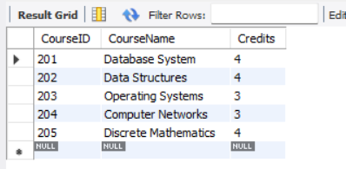
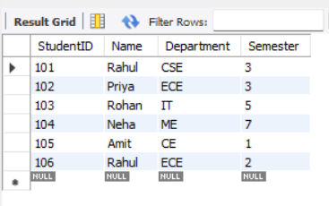
Display all records in Table 1 and Table 2.

Task 4
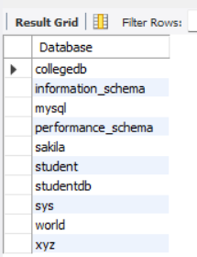
Show all databases and Tables of any database.
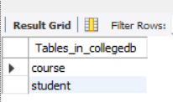

Task 5
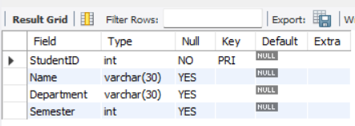
Display Schema of Student and Course Tables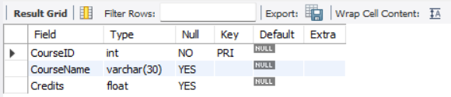

Task 6
Update Department of Student 104 and delete Student 105
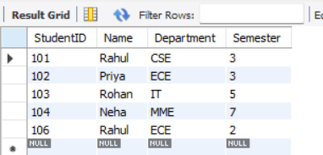

Task 7
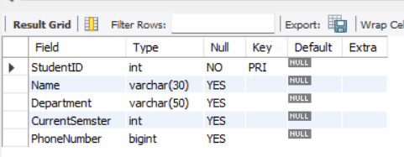
Alter Student Table 1.Modify Department 2.Rename Semester to CurrentSemster 3.Drop PhoneNumber

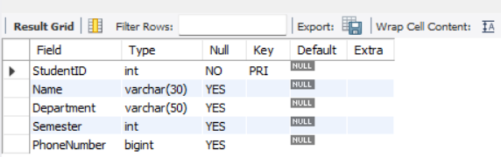
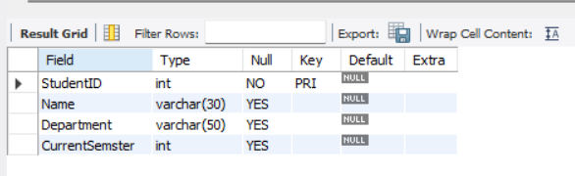
Task 8
Rename Student to Student_Record
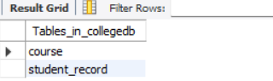

Task 9
Truncate Course table and insert two new records
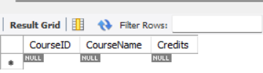
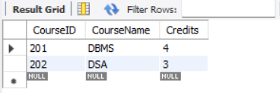

Task 10
Drop Student_Record, Course and CollegeDB
